**Project Planning Phase**

**Project Planning Template (Product Backlog, Sprint Planning, Stories, Story points)**

|  |  |
| --- | --- |
| Date | 14 April 2025 |
| Team ID | SWTID1743172790 |
| Project Name | Social Media Web App |
| Maximum Marks | 5 Marks |

**Product Backlog, Sprint Schedule, and Estimation (2 Marks)**

| **Sprint** | **Functional Requirement (Epic)** | **User Story Number** | **User Story / Task** | **Story Points** | **Priority** | **Team Members** |
| --- | --- | --- | --- | --- | --- | --- |
| Sprint-1 | User Authentication | USN-1 | As a user, I can register and log in using my email and password. | 10 | High | Komal Baid |
| Sprint-1 | Profile Management | USN-2 | As a user, I can create, edit, and view my profile details. | 6 | High | Shreya |
| Sprint-2 | Post Management | USN-3 | As a user, I can create, edit, delete, and view posts with captions and images. | 8 | High | Shreeya |
| Sprint-2 | Like, Comment, Share | USN-4 | As a user, I can like, comment on, and share posts with others. | 8 | Medium | Vanshika |
| Sprint-3 | Explore and Follow Functionality | USN-5 | As a user, I can explore posts from other users and follow/unfollow them. | 12 | High | Shreya |
| Sprint-4 | Alerts | USN-6 | As a user, I can chat in real-time using web sockets. | 10 | Medium | Komal |
| Sprint-4 | Reporting and Analytics | USN-7 | As a user, my account and messages should be secure and private. | 6 | High | Shreeya |

**Project Tracker, Velocity & Burndown Chart: (2 Marks)**

| **Sprint** | **Total Story Points** | **Duration** | **Sprint Start Date** | **Sprint End Date (Planned)** | **Story Points Completed (as on Planned End Date)** | **Sprint Release Date (Actual)** |
| --- | --- | --- | --- | --- | --- | --- |
| Sprint-1 | 16 | 5 Days | 24 March 2025 | 29 March 2025 | 16 | 29 March 2025 |
| Sprint-2 | 16 | 5 Days | 30 March 2025 | 3 April 2025 | 16 | 3 April 2025 |
| Sprint-3 | 12 | 5 Days | 4 April 2025 | 9 Aril 2025 | 12 | 9 Aril 2025 |
| Sprint-4 | 16 | 5 Days | 9 April 2025 | 14 April 2025 | 16 | 14 April 2025 |

**Velocity:**

Imagine we have a 10-day sprint duration, and the velocity of the team is 20 (points per sprint). Let’s calculate the team’s average velocity (AV) per iteration unit (story points per day)

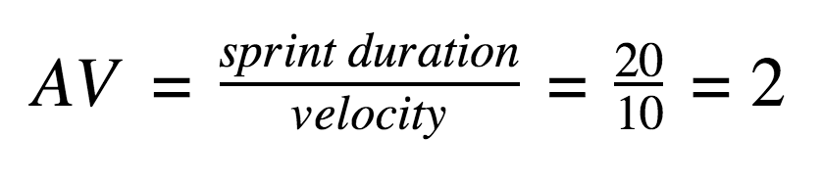

|  |  |  |  |
| --- | --- | --- | --- |
| **Sprint** | **Sprint Duration** | **Velocity** | **Average Velocity = Sprint duration/ velocity** |
| Sprint 1 | 5 days | 16 | 3.2 story points/ day |
| Sprint 2 | 5 days | 16 | 3.2 story points/ day |
| Sprint 3 | 5 days | 12 | 2.4 story points / day |
| Sprint 4 | 5 days | 16 | 3.2 story points/day |

**Burndown Chart:**

A burndown chart is a graphical representation of work left to do versus time. It is often used in agile[software development](https://www.visual-paradigm.com/scrum/what-is-agile-software-development/) methodologies such as [Scrum](https://www.visual-paradigm.com/scrum/scrum-in-3-minutes/). However, burn down charts can be applied to any project containing measurable progress over time.

